Rules and Constitution

Issue iv
September 2022

Issued January 2006

1. Name

2. Objects/Aims

3. Membership

4. Duties of Members

5. Subscription

6. Resignation

7. Committee and Officers

8. Elections of Committee

9. Minutes

10. Meetings

11. Arrangements for General Meeting

12. Financial Year

13. Expenses and Payments

14. Dissolution

15. Membership of the GCCF

16. Alteration of the Rules

17. General
1 Name.
a) The name of the Club shall be the ‘Selkirk Rex Cat Club’ and is afterwards referred to in these rules as the 'Club'.

2 Objects/Aims.
The objects of the club are: -
- To promote, develop and safeguard the interests of the Selkirk Rex Breed.
- To participate in any appropriate GCCF Scheme with the appropriate Breed Advisory Committee:
  - Formulate and recommend revision, where necessary, of the Standard of Points and Registration Policy for the Selkirk Rex.
  - To select prospective judges of the breed and recommend them to GCCF for approval.
  - To make recommendations to the GCCF on all matters related to the breed.
- To provide the means for the meeting together of persons interested in the Selkirk Rex Breed, for their mutual benefit and to safeguard the future and well-being of the Selkirk Rex Breed.
- To hold exhibitions and shows, competitions and other functions in connection with the Selkirk Rex Breed.

3 Membership
The Club shall consist of:
  - Founder Members
  - Ordinary Members
  - Junior Members
  - Honorary Members
All persons shall be eligible for membership.
- Founder Members are those who joined the Club on the 15th January 2006. Founder Members shall have the same privileges as ordinary Members.
- Applications for membership shall be in writing, giving details of the name(s) of the candidate(s) in full, his/her/their residence, accompanied by the payment of the annual subscription in force at the time. Such applications can be made on forms designed for the purpose addressed to the membership secretary. If possible applicants should be sponsored by an existing member. All membership applications will then be processed through the Club Treasurer.
- Acceptance of application for membership shall be subject to a majority vote of the committee who reserve the right to refuse any application. Any such refusal shall be communicated to the applicant in writing and the annual subscription fee will be refunded.
- Following acceptance by the Committee, a welcome letter, together with a copy of the Club Rules, shall be sent to all new members.
- Honorary members shall be persons who, in the opinion of the Committee, have rendered exceptional service to the Selkirk Rex breed. The appointment will be confirmed at the next AGM. Honorary members shall enjoy all the rights and benefits of membership except that they have no voting rights.
- If, in the opinion of the Committee, the conduct of any member has been prejudicial to the welfare, breeding or exhibiting of cats, or likely to prove injurious to the character, reputation, or interest of the Club, the Committee may, after giving such a member an opportunity to being heard determine either:
i) To give warning to such Member if mitigating circumstances should so warrant.
ii) To expel such a Member from the Club.
- Should there be a decision to expel the said Member from the Club, this Member will be given full details of the reasons why their expulsion is being sought in writing, and given 14 days to respond to those matters and have the right of appeal at a Special General Meeting. Should the motion to expel the Member be passed by a simple majority of those present and voting, the person whose expulsion is sought shall cease to be a Member forthwith.
- If a member has been suspended by the GCCF, he or she will automatically be suspended by the Club for the same period. Any such member wishing to rejoin the Club after expiration of their suspension must apply to the Club Committee for re-admission.

4 Duties of the Members.
- Membership of the Club shall be taken to imply acceptance by the member of the objects of the Club and its Rules. Every member shall strive to further the purposes for which the club exists.
- The Members of the club shall be bound by the rules and disciplinary powers of the GCCF at any time prevailing, in accordance with the GCCF Constitution.
- All Officers or members who under these rules or in pursuance of these rules have custody of any books, documents, accounts, property or monies belonging to the Club shall, on request, surrender them to the Committee.

5 Subscription
- The rates of subscription shall be determined from time to time by Members in the General Meeting. Two persons resident at the same address can become joint Members on payment of a joint subscription.
- All annual subscriptions shall be payable on 1st January in each year and if the subscription has not been paid on or before the annual AGM following, the defaulter shall cease to be a Member of the Club.
- The Committee may, exceptionally, on satisfactory explanation being given, allow such defaulter to be re-admitted to Membership on payment of all arrears.
- No Member whose subscription is overdue shall be entitled to vote at an AGM or Special Meeting.

6 Resignation.
- Any Member may resign his/her/their Membership by giving to the Secretary notice in writing to that effect. If that notice be given after 1st March in any year, he/she/they shall be liable to pay the subscription for that year. Any such member having discharged all his/her/their liabilities to the Club, on wishing to rejoin may do so in accordance with rule 3.
- Any Member, on ceasing to be a member of the Club, shall forfeit all rights to, and claims upon the Club, its property and funds.

7 Committee and Officers.
a) The Management of the Club (except as otherwise provided by
these rules) shall be deputed to a Committee consisting of a:
Chairman
Secretary
Treasurer (hereinafter together called ‘the Officers’)
Plus at least 4 other committee members
- One third of the Committee shall retire annually in rotation and shall be eligible for re-election; this will include one Officer and up to 3 Committee members.
- In the event of a vacancy arising on the Committee, the Committee may co-opt a Member, who shall have {no} voting powers. This member may then stand for election at the next AGM and then fulfil the term of office for the vacant position.
- At the Annual General Meeting the Officers and members of the Committee who are due to retire shall be eligible for immediate re-election. Voting shall be by ballot and every Member present shall be entitled to vote for as many candidates as there are vacancies to be filled. Voting will take place by ballot of those present. The candidates up to the number of vacancies who shall receive most votes shall be declared elected and, in the case of two or more candidates receiving an equal number of votes, the Chairman shall have a second or casting vote.
- The Committee shall meet as frequently as may be necessary to examine the Accounts and arrange the affairs of the club, but at least three times a year. At least twenty-eight days notice of every meeting of the committee shall be given to every member of the Committee, and the Agenda and Minutes shall be circulated not less than seven days before the date of each meeting. A quorum shall consist of 6 members of the Committee including at least one Officer. A member of the Committee absenting himself/herself from three consecutive Committee meetings without reasonable cause shall be deemed to have retired from membership of the Committee.
- The role of Hon. President is bestowed on an individual that has been deemed to have offered an outstanding contribution to the Selkirk Rex Breed. No duties are imposed upon him/her apart from sympathy with the objects of the club. The Hon. President shall have no voting rights.
- The Committee shall have the power to propose a President and Vice- President(s) to serve for an indefinite period.
  - Their name(s) shall be submitted for approval to the AGM.
  - These offices are honorary and no duties are imposed apart from sympathy with the objects of the Club.
- The Chairman shall have only a casting vote whilst the Vice-Chairman has a vote unless standing in as Chairman and then shall only have a casting vote.
- THE HON SECRETARY shall:
i) Conduct correspondence on behalf of the Club.
ii) Maintain a copy of the register of members.
iii) Call meetings by arrangement with the Chairman.
iv) Keep minutes of all meetings.
v) Notify members of their election.
vi) Prepare the annual returns for the GCCF on the official form and return them by the due date.
vii) Report annually to the members on the work of the Committee.
viii) The above duties may be apportioned to a Membership Secretary and/or a Minutes Secretary at the discretion of the Committee.
j) THE HON TREASURER shall:
i) Maintain a register of members.
ii) Hold all the monies received on behalf of the Club in accounts opened on authorisation by the Committee.
iii) Defray on behalf of the Club all expenses properly and necessarily incurred by the Officers and Committee and those members of the Club for purposes considered appropriate.
iv) submit to the GCCF a copy of the accounts which have been examined and signed by a suitably independent person for the previous year in the form of an income and expenditure account with a supporting balance sheet including analysis of the subscription income and a statement of paid-up members including life members.
v) Ensure that the Club’s dues are paid to the GCCF and the financial returns submitted by the date due.
vi) Provide copies of the accounts to all members at the AGM and for all other members who apply in writing for them.

8 Election of Committee
- Committee members shall be elected for three years and are eligible for re-election.
- The Officers, i.e. Chairman, Hon Secretary and Hon Treasurer, shall be elected in turn for a 3 year period by the Committee.
- Retiring Officers are eligible for re-election.
- Nominations for Officers and Committee shall be invited at the time of notification of the Annual General Meeting. All nominations shall be in writing,

9 Minutes.
Minutes shall be taken of all proceedings of the Committee and shall be open to the inspection of any member of the club upon formal application to the secretary.

10 Meetings.
- The Annual General Meeting shall be held not later than 31st December each year. 6 members shall be a quorum.
- Notice of the AGM shall be sent to fully paid-up members at least two calendar months before the date.
- All matters for the agenda and nominations for Committee shall reach the Secretary at least 6 weeks in advance.
- All members shall be sent an Agenda.
- The business of the AGM shall include:
- Secretary’s report
- Presentation of the accounts by the Treasurer
- Approval of the accounts
- Elections of Officers, Committee and Delegates
- Appointment of a suitably independent person to examine the accounts
- Consideration of resolutions proposed by the Committee or by two or more members
- AOB
- Other General meetings may be held as required at a time and place appointed by the Committee.
- Special General Meetings may be called by the Committee or by the
Secretary on behalf of the members. Twelve members of the Club should request the Secretary in writing for such a meeting, stating clearly the object of the meeting which shall not conflict with these rules. The request must be signed by each of the supporting members. The Secretary must summon the meeting within one calendar month of the date of the request and should ensure that three week’s notice of the Special Meeting is given to all members, pointing out that only the matter designated in the request for a meeting may be discussed and that no other business may be conducted.
- Thirteen members shall be a quorum for the meeting and the members requesting the meeting shall be responsible for the expenses incurred unless otherwise determined by the meeting.
- Committee meetings shall be held as often as the Chairman deems necessary three times a year. A quorum shall consist of six voting members of the Committee including at least one Officer. Fourteen days’ notice shall be given and the agenda issued in advance of the meeting.
- The Chairman of the Club shall preside at every General, Special and Committee meeting. In the absence of the Chairman the Vice-Chairman shall preside or in the absence of both, a chairman may be appointed by the meeting.
11 Voting
- At all meetings every member present except the Chairman shall have a vote and all matters shall be decided by a simple majority of those present.
- In the event of an equality of votes the presiding officer shall have an additional or casting vote.
- Voting by proxy is not allowed.
- On points of order the presiding officer’s decision is final.
- The Chairman shall have only a casting vote whilst the Vice-Chairman has a vote unless standing in as Chairman and then shall only have a casting vote

12 Financial year.
The financial year of the club shall end on 31st December of each year, to which date the Accounts of the club should be balanced.

13 Expenses and Payments.
- Any reasonable expense incurred by the club Secretary and the Treasurer on behalf of the Club, and by delegates duly appointed, shall be defrayed out of the funds of the club. Any item in excess of £50 will be subject to approval by the Committee.

14 Dissolution.
Any proposal to dissolve the club shall be considered only at a Special General meeting and shall be approved only upon a vote of assent from two thirds of the members present and voting. If such a resolution shall be passed, then all assets of the Club shall be disposed as follows:
a) Trophies shall, where possible, be returned to the donors or their next of kin. A notice to this effect shall be placed in the official journal of the GCCF and a period of six weeks allowed, following publication, for the claiming of such trophies. Thereafter, any unclaimed trophies will be added to the clubs general assets for disposal.
b) All remaining goods and property of the club shall be sold and the proceeds paid into the account of the Club.
c) Suitable provision shall be made for any cats in the care of the club.
d) All liabilities of the club shall be discharged.
e) The balance of funds, if any, shall be used for cats’ welfare at the discretion of the Committee.

15 Membership of the GCCF
- As a GCCF Member Club, the Club's delegates shall be members of the Committee and shall be elected by ballot at the AGM and shall hold office during the immediately succeeding year of the Governing Council. Should the club have one delegate, another member of the committee, elected by ballot at the AGM, shall be named reserve.
- The members of the Club shall be bound by the Rules and disciplinary powers of the GCCF.
- The GCCF shall have disciplinary powers in regard to the members of the Club, in accordance with the GCCF Constitution.

16 Alteration of the Rules.
These rules may be altered at an Annual General Meeting or Special General Meeting of the club. Particulars of alterations or additions shall be made only if two-thirds of members present, and voting shall vote in favour.

17 General.
The Committee shall be authorised to deal with any matters affecting the Club which are not provided for by these rules.

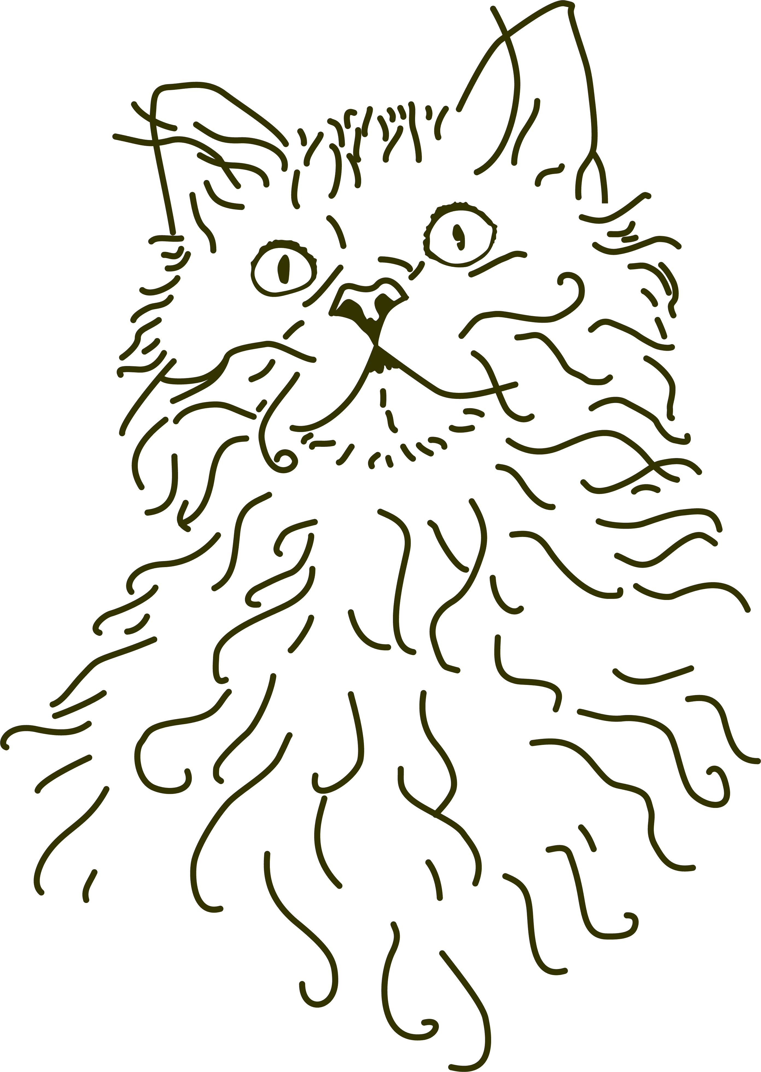
Visit the Selkirk Rex Cat Club dedicated website –
http://www.selkirkrexcatclub.co.uk/

© Selkirk Rex Cat Club 2006
Re-print 4
Publication date 08.02.2010

